Task 1: Provision the lab environment

In this task, you will deploy three virtual machines, each into a separate virtual network, with two of them in the same Azure region and the third one in another Azure region.

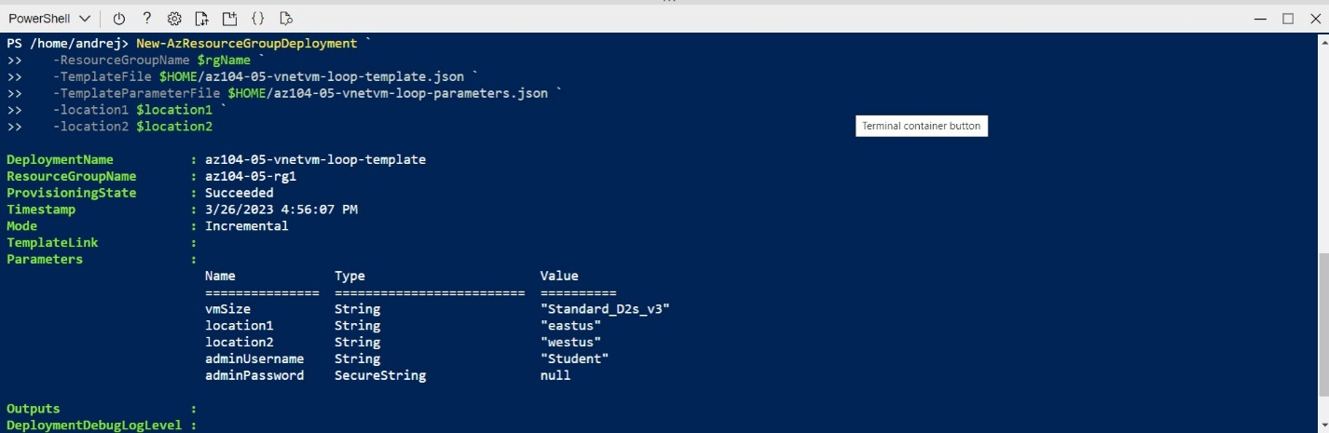

#### Task 2: Configure local and global virtual network peering

In this task, you will configure local and global peering between the virtual networks you deployed in the previous tasks.

* This step establishes two local peerings - one from az104-05-vnet0 to az104-05-vnet1 and the other from az104-05-vnet1 to az104-05-vnet0.

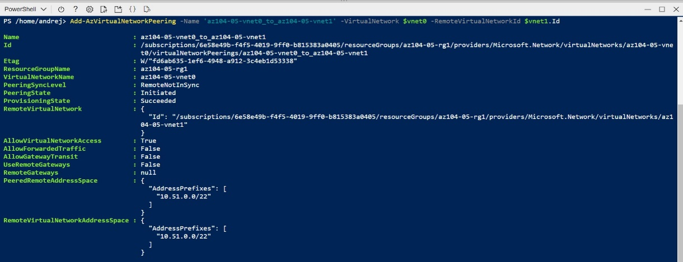

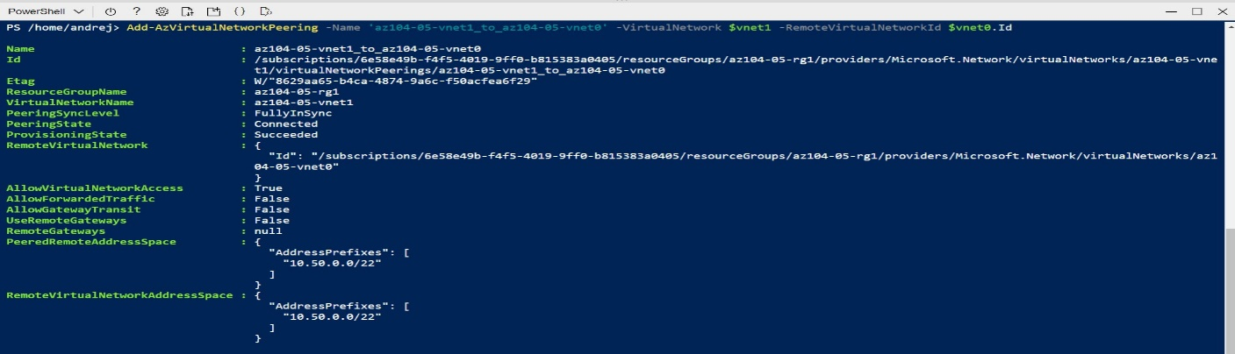

* This step establishes two global peerings - one from az104-05-vnet0 to az104-05-vnet2 and the other from az104-05-vnet2 to az104-05-vnet0.

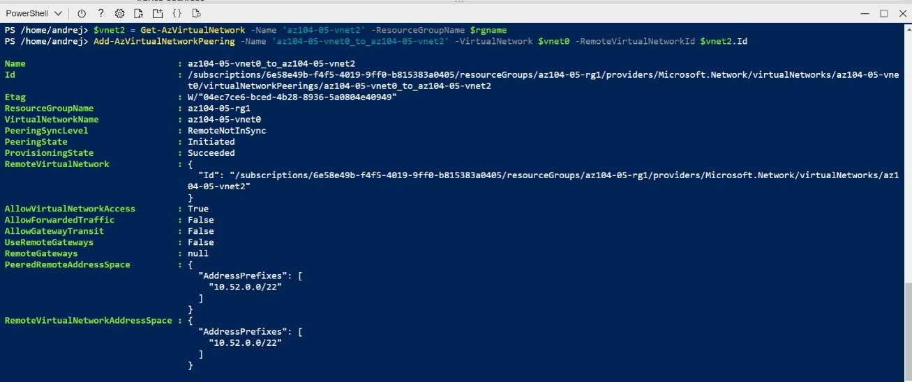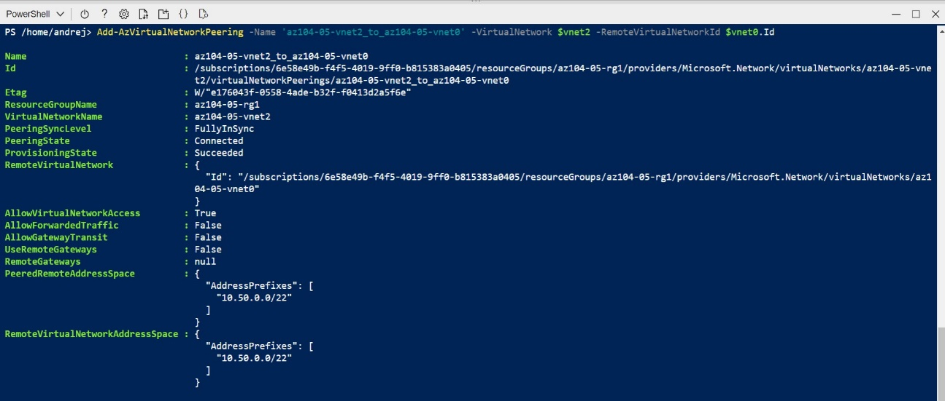

 This step establishes two global peerings - one from az104-05-vnet1 to az104-05-vnet2 and the other from az104-05-vnet2 to az104-05-vnet1.

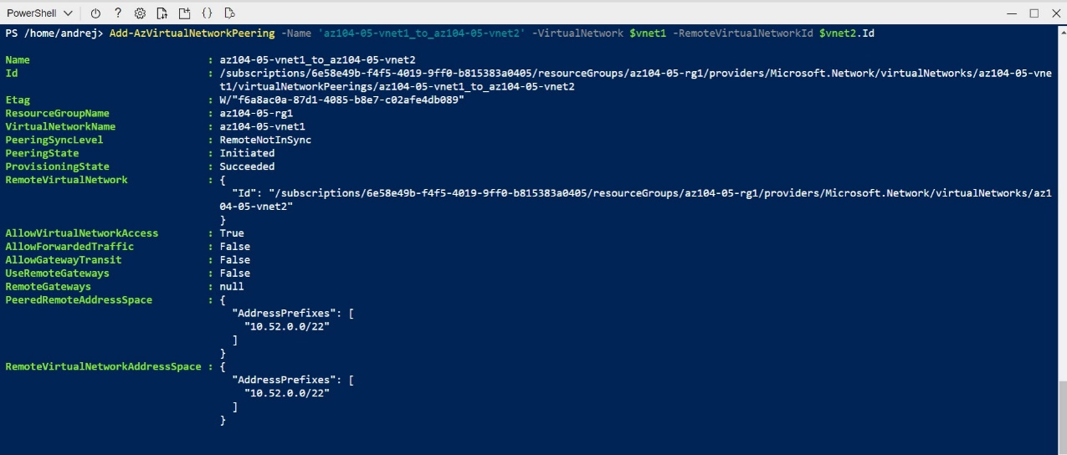

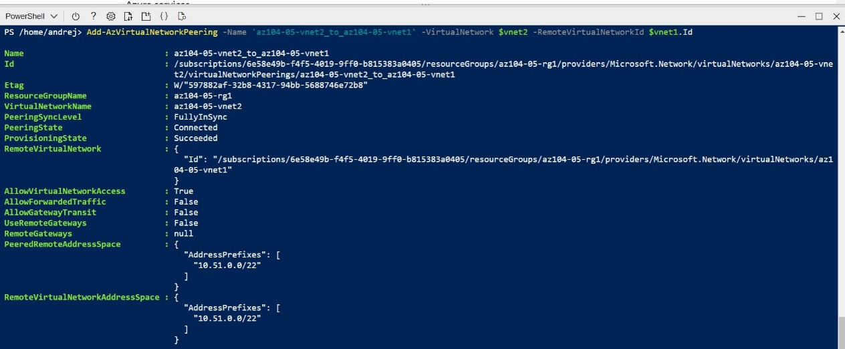

#### Task 3: Test intersite connectivity

#### In this task, you will test connectivity between virtual machines on the three virtual networks that you connected via local and global peering in the previous task.

1. Within the Remote Desktop session to **az104-05-vm0**, right-click the **Start** button and, in the right-click menu, click **Windows PowerShell (Admin)**.
2. In the Windows PowerShell console window, run the following to test connectivity to **az104-05-vm1** (which has the private IP address of **10.51.0.4**) over TCP port 3389:

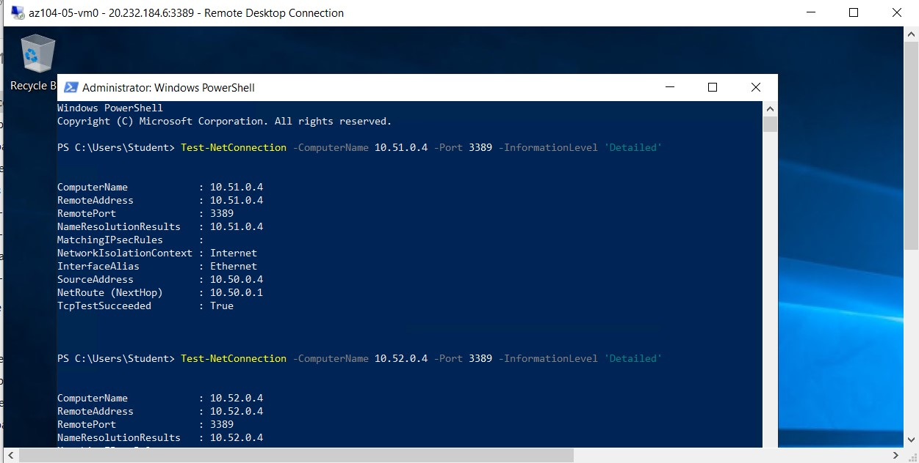

1. Within the Remote Desktop session to **az104-05-vm1**, right-click the **Start** button and, in the right-click menu, click **Windows PowerShell (Admin)**.
2. In the Windows PowerShell console window, run the following to test connectivity to **az104-05-vm2** (which has the private IP address of **10.52.0.4**) over TCP port 3389:

